Your Guide to Visiting Pikes Peak
There Are so Many Ways You Can Enjoy the Beauty and Wonder of America’s Mountain

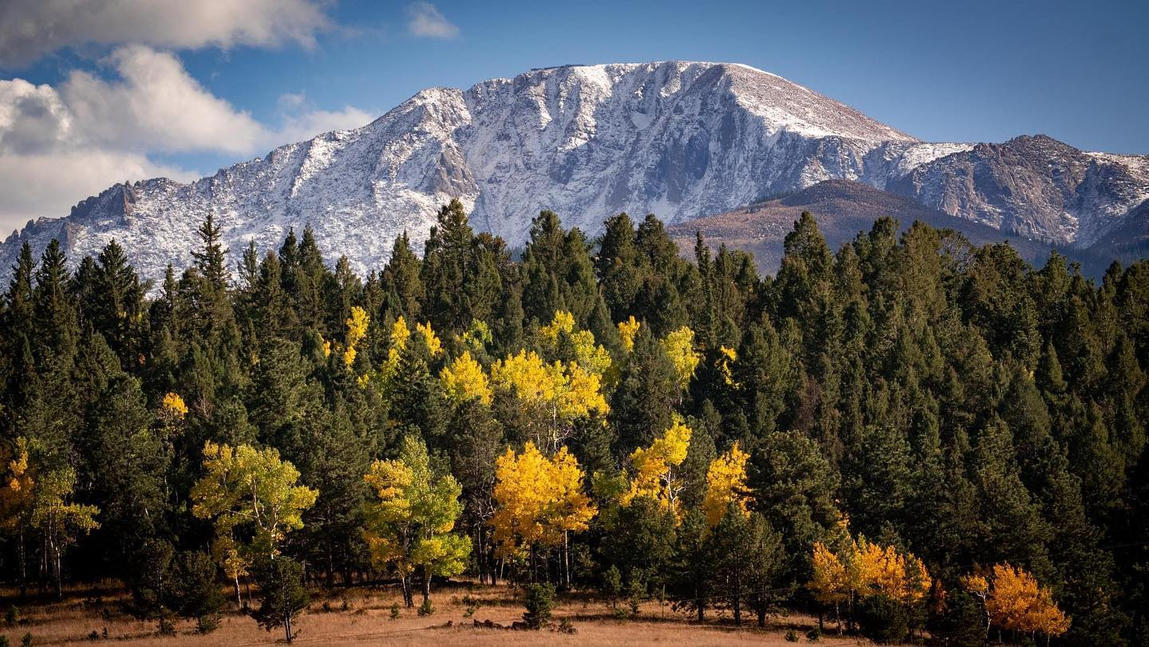
Pikes Peak | Photo Credit Pikes Peak Facebook
Pikes Peak is Colorado’s most prominent mountain. This majestic mountain is so popular that it has been nicknamed America’s Mountain. This nickname comes from the fact that Pikes Peak is the most visited mountain in North America, and the second most visited mountain in the World! On a clear day, you can see five different states from the summit, Colorado, Arizona, New Mexico, Kansas, and Utah.
Why Visit
Pikes Peak not only offers stunning views and breath-taking scenery, but it’s also very accessible. This famous mountain is easy to travel to, offers several ways to reach the summit, and has plenty of recreation opportunities for everyone!
With an elevation of 14,115 feet, Pikes Peak is also a “fourteener”, aka a mountain that’s over 14,000 feet above sea level. There are 96 fourteeners in the USA and Colorado has 53 of them. From Colorado Springs to the top of Pikes Peak there’s a gain of 8,000 feet in elevation!
Travel Tip: If you are visiting from an area with a lower elevation, take time to adjust before travelling up Pikes Peak or you might find yourself afflicted with elevation sickness.
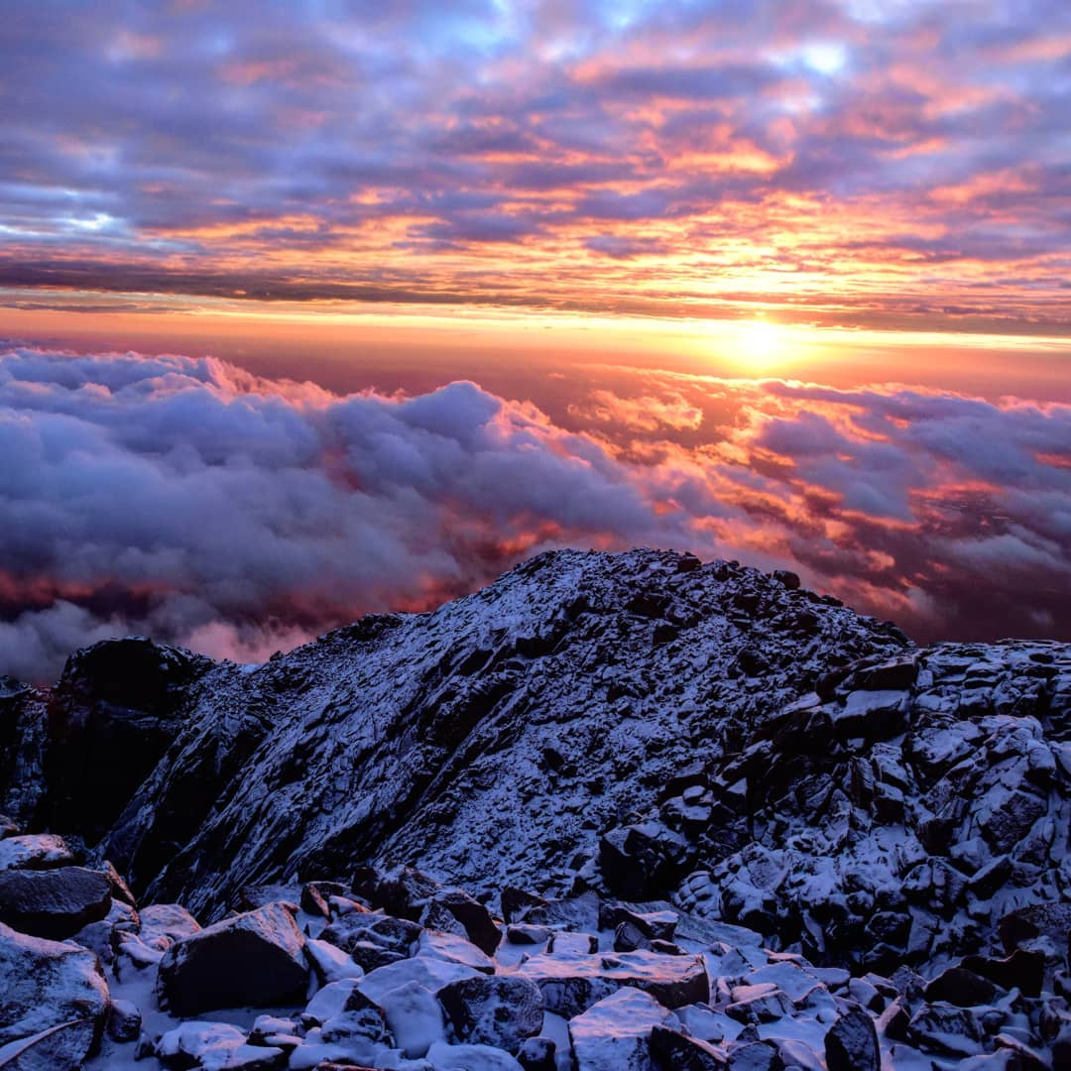
Sunrise From Pikes Peak | Photo Credit Pikes Peak Facebook
How to Reach the Summit
Option 1: You can drive your car right up to the top of Pike’s Peak! Pikes Peak highway is 19 miles of gorgeous mountain terrain, and the road is paved all the way to the summit.
Pros: Budget-friendly (there is a toll fee of $15 per passenger), this option allows the most freedom, you can stop whenever you want to take pictures, look at wildlife, have a picnic, bring the poles along to do some fishing, or even do some hiking around before driving back down.
Cons: Whoever’s driving will need to keep their eyes on the twisting mountain road and won’t be able to enjoy all the scenery along the way. The road can also be a little intimidating for drivers who aren’t used to mountain driving.
Travel Trip: The Southern Slope Recreation Area is a fantastic place to stop for some hiking, fishing, and bighorn-sheep spotting.
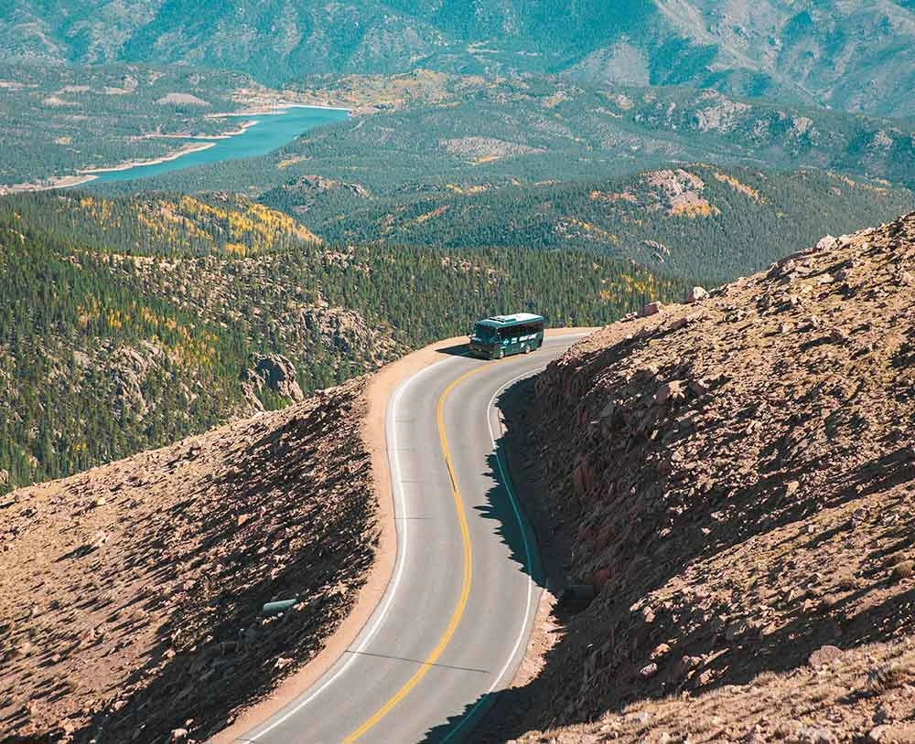
Gray Line Shuttle | Photo Credit Pikes-Peak.com
Option 2: Schedule a jeep or shuttle tour. Adventures Out West offers jeep tours up Pikes Peak starting at $149 per person. These tours allow everyone in your group to sit back, relax, and enjoy the ride while an experienced guide does all the driving. For a more affordable option, there are also shuttle tours to the summit, Gray Line offers a four-hour summit trip for $80 per person ($60 for kids 2 to 12, kids under 2 are not permitted).
Pros: Everyone in the group can look out the windows and enjoy the gorgeous views during the drive. Plus, you’ll have a friendly and knowledgeable tour guide who can help you learn more about the mountain. The Gray Line also makes several stops along the way, including Crystal Reservoir (a stunning 136-acre lake).
Cons: You’re only given a limited block of time to explore at each stop and about 30 minutes at the summit.
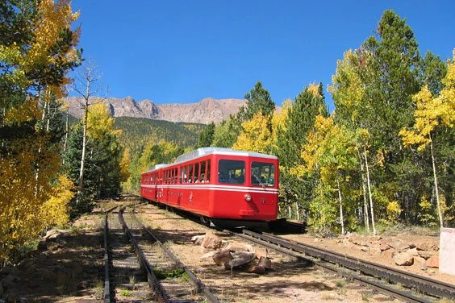
Pikes Peak Cog Railway | Photo Credit Pikes-Peak.com
Option 3: Ride the Train! The Pikes Peak Cog Railway has been in operation since 1891. The railway has been recently renovated, with a new depot, new and refurbished trains and over nine miles of new tracks. The Cog Railway is once again offering a unique and delightful way to travel up and down Pikes Peak. Prices start at $58 per adult and $48 for kids 12 and under.
Pros: The train offers a fun and unique way to reach the summit. During the nine-mile journey, the train also provides exceptional views of the Pikes Peak region that typically only experienced backcountry hikers get to see, and before leaving the train depot, visitors also have the option to buy drinks, locally made Colorado snacks, sandwiches, ice cream, and trail mix to enjoy during the train ride.
Cons: There are no stops along the way for breaks or pictures. However, you do get about 40 minutes to explore at the summit before the train departs for the journey back down.
Travel Tip: During the summer the train often sells out a couple weeks in advance so be sure to book your trip early!
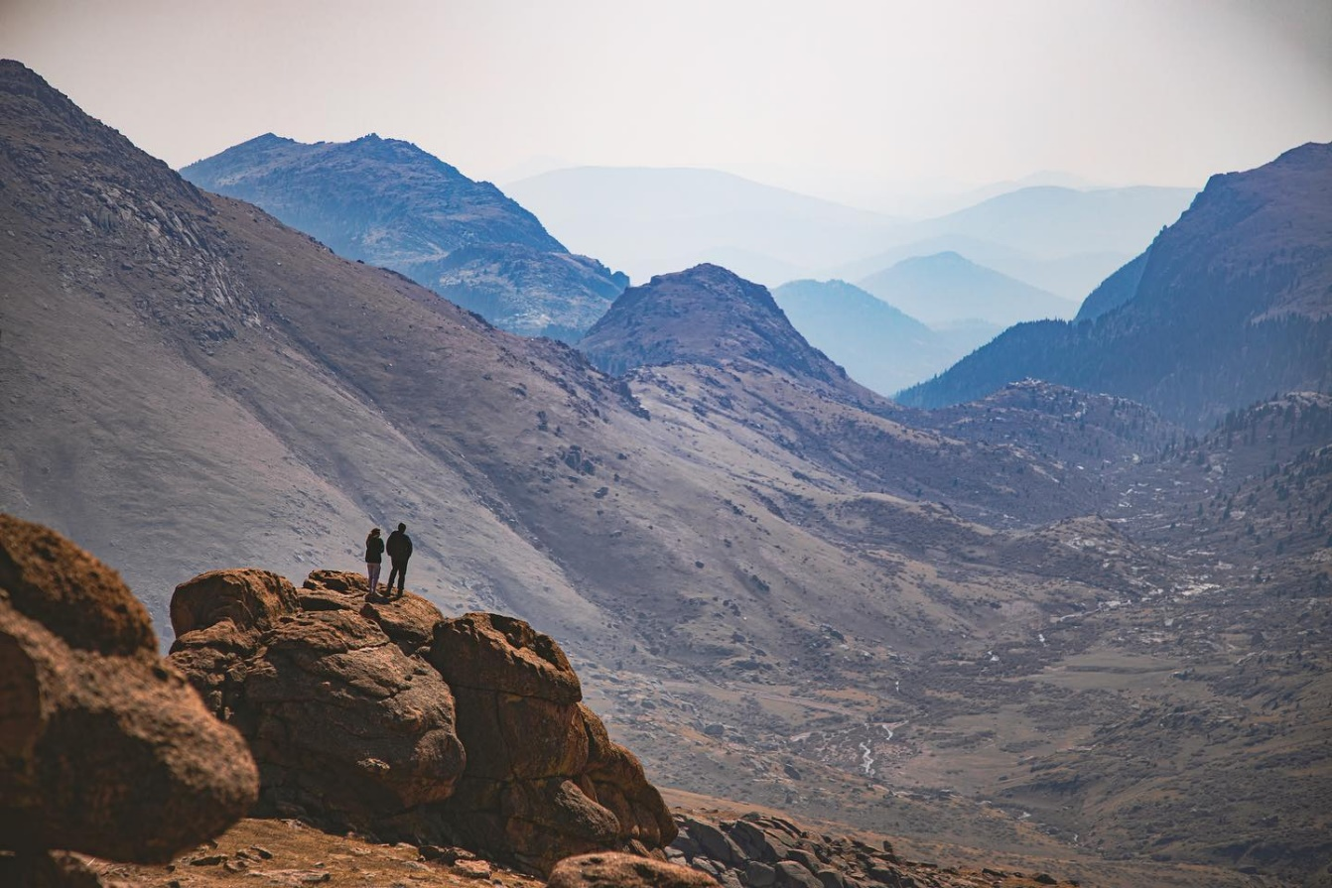
Hiking Pikes Peak | Photo Credit Pikes Peak Facebook
Option 4: Hiking! Yes, as daunting as it seems, hiking 13.5 miles (one-way), with an elevation gain of about 7,500 feet is an option. Hikers can take Barr’s Trail all the way to the summit. This is a strenuous and challenging hike, that only experienced and healthy hikers should attempt. Also, keep in mind that during the final three miles the oxygen is very thin, which can make breathing while hiking more difficult. If you choose to hike, bring plenty of water as there is nowhere to fill up along the trail.
Pros: Getting out in nature, seeing the incredible sights along the trail, sense of pride and achievement for hiking a fourteener. Not to mention you’ll get a good workout!
Cons: Physically tough and tiring, this hike takes anywhere from 8 to 16 hours (one way) and is usually done over a couple days.
Travel Tip: The Cog Railway allows you to book a one-way ticket up or down the mountain for hikers who prefer to only hike one-way.
Option 5: Ride a bike! Challenge Unlimited provides a van ride to the summit, and then all the gear needed to have an exhilarating bike ride 19.5 miles down Pikes Peak. If you want an exciting cycling adventure than this option is for you.
Pros: A thrilling adventure, the company takes care of all the details and gear for you, great scenic views.
Cons: On the pricey side at $225 per person, risk of injury.
What To Do at The Summit
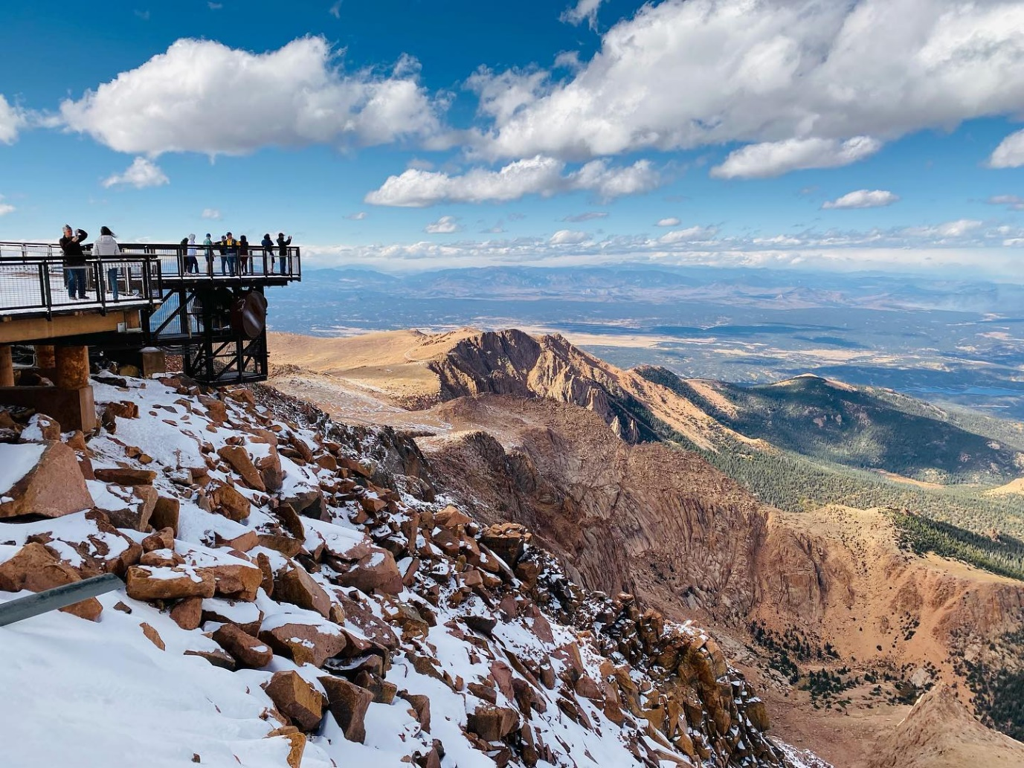
Overlook at Pikes Peak Visitor Center | Photo Credit Pikes Peak Facebook
You’ve made it to the top of Pikes Peak! Now What? Once you make it to the summit you can take in the incredible views, snap plenty of photos, and then explore the Summit Visitor’s Center. Keep in mind, the weather at the summit can be chilly, even in the summer, so come prepared with layers. At the visitor’s center you can warm up with a cup of coffee or hot chocolate and grab some lunch. You can also explore the visitor’s center interactive exhibits and visit the gift shop.
Travel Trip: Make sure to try some of the famous high-altitude donuts!
Pikes Peak Events
There are a few events that take place around Pikes Peak every year. One of these events is the Pikes Peak Marathon & Ascent. This is the oldest continually held marathon in the United States!
Another popular event is the Pikes Peak International Hill Climb—The Race to the Clouds. This is an invitational automobile race that began in 1916. This race has grown into an international event that attracts the very best drivers from around the world.

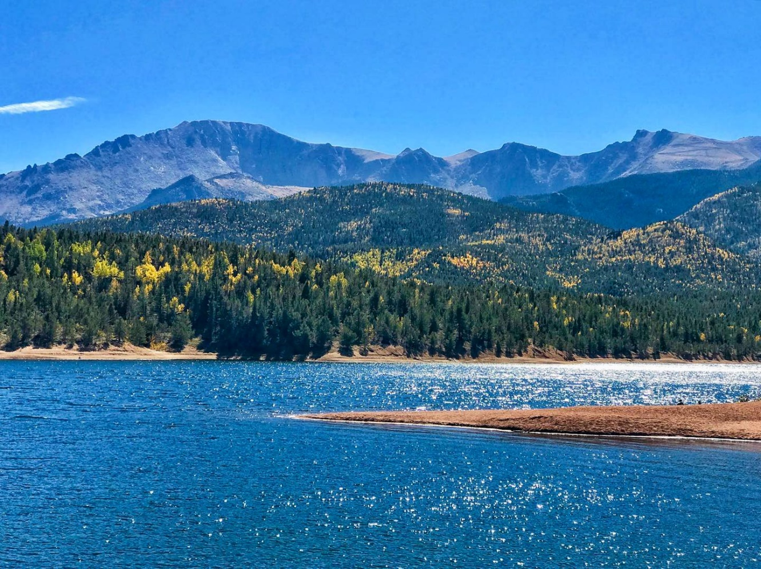
Crystal Reservoir at Pikes Peak | Photo Credit Pikes Peak Facebook

Explore Beyond Pikes Peak
After you’ve finished your mountain excursion, there’s plenty of exciting things to do around the Colorado Springs area. We compiled a list of family-friendly activities, found here. Or, if relaxing at a brewery is more your speed, we have some great recommendations listed here.
And of course, an always fun and delicious way to explore downtown Colorado Springs is by taking a food tour with us, Rocky Mountain Food Tours! There are three different tours available featuring Colorado food, local craft beer, or delicious cocktails. Public tours run every week, year round, check out our tours here.
Cheers! Your Rocky Mountain Food Tours Team

(So, what’s a food tour, anyway…?)

