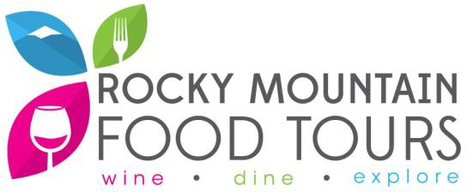
Gift Certificate Request Form

Date of Event: Deadline to Receive Gift Certificate:

Number of Gift Certificates Requested:

Note: All gift certificates will be “general” in that they can be applied to any available tour. They will have the redemption period of 12 months past the date of the charitable event. Currently, the average retail price for one food tour ticket is $58.99; therefore, a request for two tickets would equal a retail value of $117.98.

Organization Name:
Contact Info

Address: Phone Number:

Primary Contact: Title:

Email Address: Cell Phone:

Is this organization a registered 501c3?

Yes No

Event Name:
Event Description

Purpose/Goal of Event:

Approximate Number of Guests Expected: Event Location:

How will the gift certificates be displayed/advertised to your guests/invitees?

What other things might you need from us beyond the gift certificates themselves?

Logo
Frame or Stand for Display
Brochures to Give to Guests
Other

Other Information:

Please be aware that we have a set number of gift certificates we donate to local charities throughout the year, and we may not be able to honor all requests. Because of the high value of our tickets, we wish to remain as an individual item and not be placed within a larger basket or giveaway.

When complete, please return this form to jentre@rockymountainfoodtours.com.

Updated: 06/25/21

